|  |  |  |  |
| --- | --- | --- | --- |
| 2 | | 39,384 | |
| **NUMERO DE FRONTERAS** | | **ENERGIA AGREGADA** | |
|  | | | |
| 6,634,350 | 35 | | 282,990 |
| INGRESO 2019 | DÍAS CERTIFICADOS 2019 | | ENERGIA RESPALDADA 2019 |
|  | | | |
| 77,066,219 | 198 | | 2,915,797 |
| INGRESO 2020 | DÍAS CERTIFICADOS 2020 | | ENERGIA RESPALDADA 2020 |
|  | | | |
| 62,130,768 | 88 | | 2,716,807 |
| INGRESO 2021 | DÍAS CERTIFICADOS 2021 | | ENERGIA RESPALDADA 2021 |

**HISTORICO REINTEGRO DDV**

|  |  |  |  |
| --- | --- | --- | --- |
|  | **2019** | **2020** | **2021** |
| **ENE** | - | 8.58 | 7.33 |
| **FEB** | 3.14 | 10.76 | 16.02 |
| **MAR** | 0.2 | 13.21 | 7.19 |
| **ABR** | 3.29 | - | - |
| **MAY** | - | 0.61 | 0.58 |
| **JUN** | - | 6.2 | - |
| **JUL** | - | 10.28 | - |
| **AGO** | - | 6.03 | - |
| **SEP** | - | 0.72 | 15.67 |
| **OCT** | - | 0.22 | 15.34 |
| **NOV** | - | 7.37 | - |
| **DIC** | - | 13.09 | - |

**Los valores de la tabla están en millones de COP**

**REINTEGRO MECANISMO DDV OCTUBRE 2021**

|  |  |  |  |  |  |
| --- | --- | --- | --- | --- | --- |
| FECHA | TIPO DIA | CANTIDADES RESPALDO | PRECIO PONDERADO USD | TRM | PNETO |
| 2021-10-01 | Viernes | 39,382 | 5.98 | 3,784.44 | 807,474 |
| 2021-10-02 | Sábado | 39,381 | 5.98 | 3,784.44 | 807,454 |
| 2021-10-03 | Domingo - Festivo | 39,381 | 5.98 | 3,784.44 | 807,454 |
| 2021-10-04 | Lunes | 39,381 | 5.98 | 3,784.44 | 807,454 |
| 2021-10-05 | Martes | 39,381 | 5.98 | 3,784.44 | 807,454 |
| 2021-10-06 | Miércoles | 39,381 | 5.98 | 3,784.44 | 807,454 |
| 2021-10-07 | Jueves | 39,381 | 5.98 | 3,784.44 | 807,454 |
| 2021-10-08 | Viernes | 39,381 | 5.98 | 3,784.44 | 807,454 |
| 2021-10-09 | Sábado | 39,381 | 5.98 | 3,784.44 | 807,454 |
| 2021-10-10 | Domingo - Festivo | 39,381 | 5.98 | 3,784.44 | 807,454 |
| 2021-10-11 | Lunes | 39,381 | 5.98 | 3,784.44 | 807,454 |
| 2021-10-18 | Domingo - Festivo | 39,381 | 5.98 | 3,784.44 | 807,454 |
| 2021-10-19 | Martes | 39,381 | 5.98 | 3,784.44 | 807,454 |
| 2021-10-20 | Miércoles | 39,381 | 5.98 | 3,784.44 | 807,454 |
| 2021-10-21 | Jueves | 39,381 | 5.98 | 3,784.44 | 807,454 |
| 2021-10-22 | Viernes | 39,382 | 5.98 | 3,784.44 | 807,474 |
| 2021-10-23 | Sábado | 39,382 | 5.98 | 3,784.44 | 807,474 |
| 2021-10-24 | Domingo - Festivo | 39,382 | 5.98 | 3,784.44 | 807,474 |
| 2021-10-25 | Lunes | 39,381 | 5.98 | 3,784.44 | 807,454 |

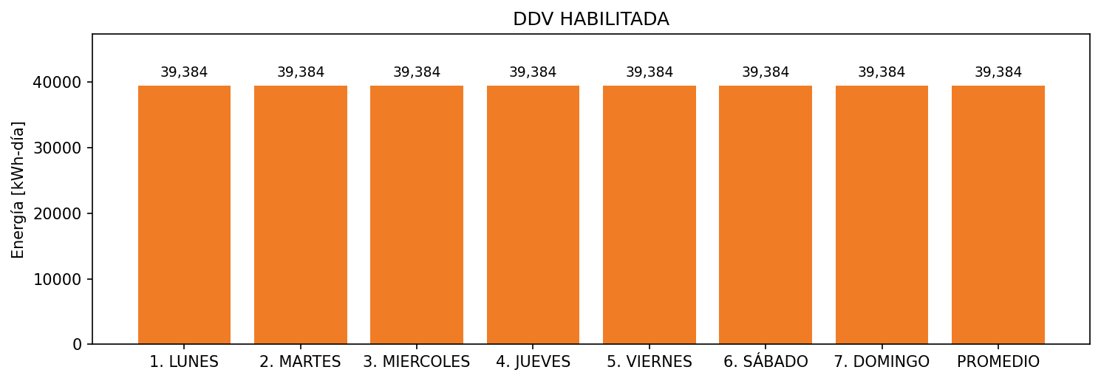

|  |  |  |  |  |  |  |  |  |  |
| --- | --- | --- | --- | --- | --- | --- | --- | --- | --- |
| **FRONTERA** | **COD SIC** | **FRT DDV** | **TIPO DDV** | **PROMEDIO** | **PRÓXIMA ACTUALIZACIÓN** | **MARGEN DE ERROR** | **ÚLTIMA PRUEBA DDV** | **DÍAS PARTICIPACIÓN** | **FECHA REFERENCIA PRÓXIMA PRUEBA DDV** |
| COLOMBINA S.A. - 1 | Frt26193 | Frt35936 | GPE | 24,984 | 2023-04-15 | NO APLICA | 2021-09-04 | 36.0 | 2022-02-03 |
| COLOMBINA S.A. - 2 | Frt26193 | Frt41381 | GPE | 14,400 | 2022-04-15 | NO APLICA | 2021-09-04 | 36.0 | 2022-02-03 |